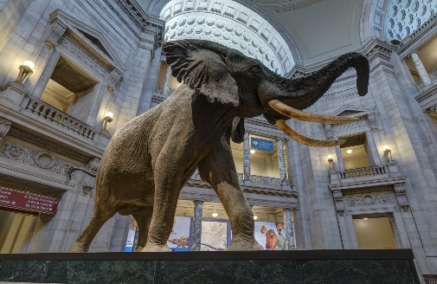
Smithsonian Museum of Natural History
SCAVENGER HUNT

Instructions for organizers
- DO NOT share the workbook or virtual museum link before the event!
- Familiarize yourself with the Player Handbook and specifically the rules outlined there. It’s also recommended that you go through a few questions yourself to get the hand of the museum and how answering questions works.
- Split team into groups of 2-5 participants. Note that this is just a recommendation for group events, people can do the hunt all by themselves.
- The Player Handbook is a series of ~50 questions that require writing an answer or taking a screenshot of the virtual tour. Each team should have their own copy, preferably somewhere it can be co-edited by the team only.
- Once you collect the submissions, go through the answers below and score accordingly. Please not that some questions are subjective, so just be consistent across teams.
- If you have feedback, bug fixes or questions email Filip K. or visit the GitHub repo. Let’s improve the game for future iterations.

Answers

# | Points | Answer
1 | 5 | = Café  This shark hangs in the café, look up!
2 | 5 | This one is in the center of ‘David H. Koch Hall of Fossils Deep Time’  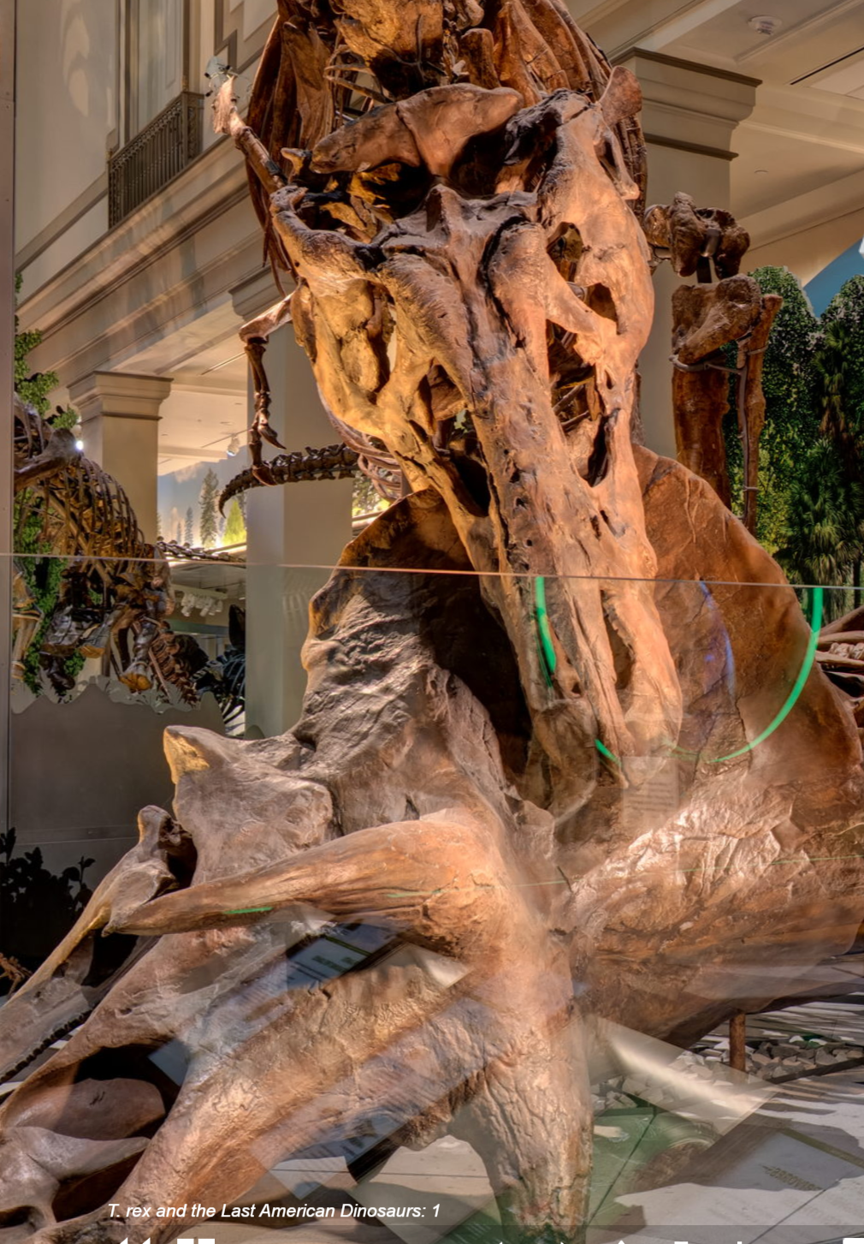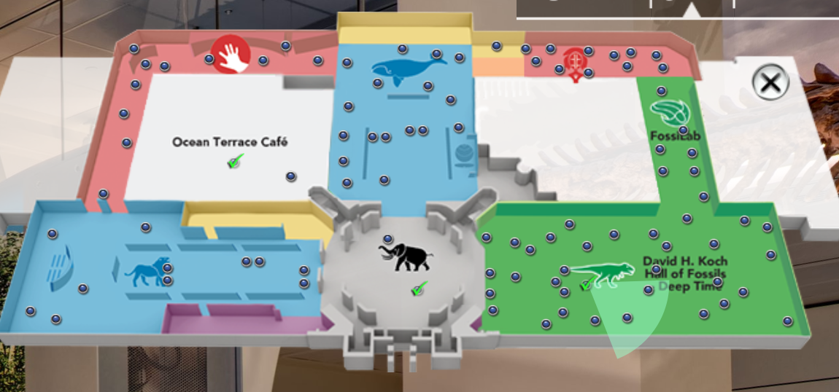
3 | 15 | =Animal mummification
4 | 10 | =Mammal Hall: Southern Hemisphere  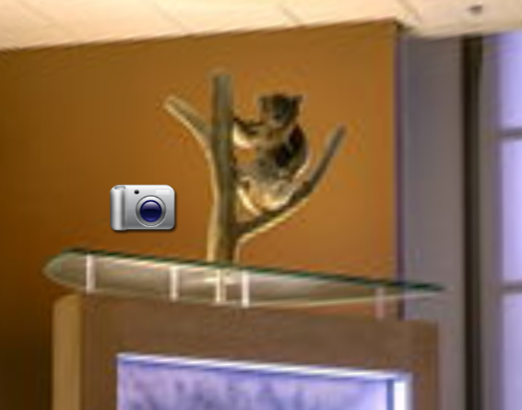
5 | 10 | = Copper Splash Sculptures  Found in the museum store.
6 | 15 | = One of the following:  - 10 or more legs in pairs  - 2 body regions: abdomen, cephalothorax  - 2 pairs of antennae
7 | 15 | =Sant Ocean Hall: Where Does it Live? Need to click the photo on exhibit  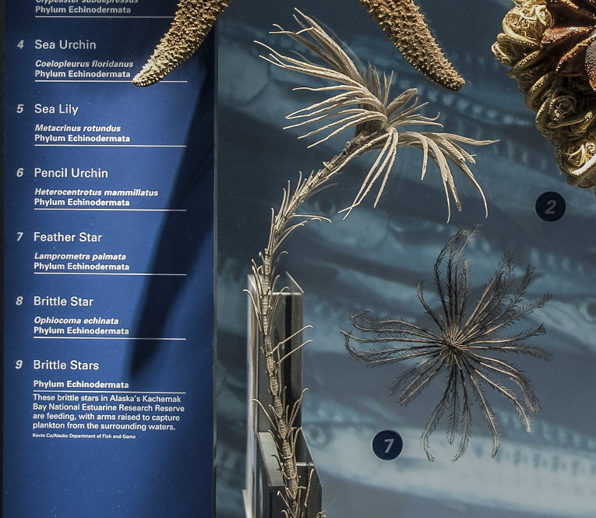  Might be another one hiding at: 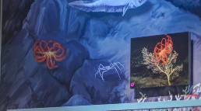
8 | 35 | = L  The statue sits on top of the letter L on it’s podium in “Q?rius 2” room.  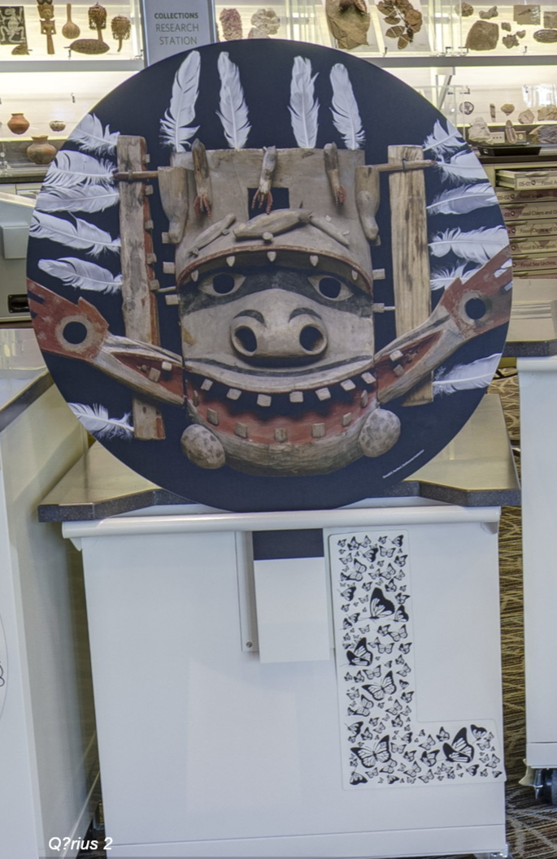
9 | 40 | =Fossil Ammonites and Cephalopods  It’s a drawer in =“Q?rius 5”  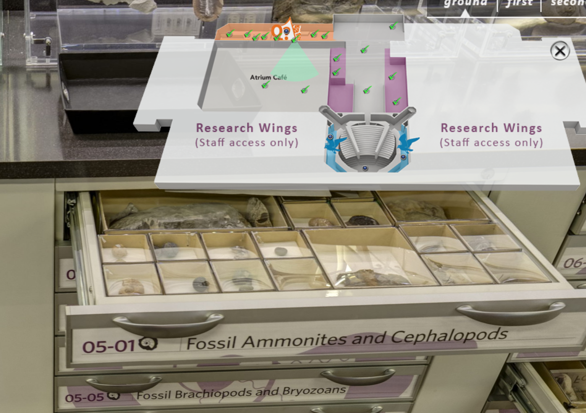
10 | 30 | =A picture of any mother you can verify = 30pts  =A picture of the REAL mummy below = 10pts  Yes, this is a trick question, as I wrote mommy instead of mummy. To get 30pts they need a picture of any mommy (ie mother), if they submit the ‘REAL mummy’ (the plaque says ‘this is a real mummy’ from ‘Special Exhibits: Egypt 1’ hall and pic below give them 10pts. If they do both, feel free to give 40pts 😊  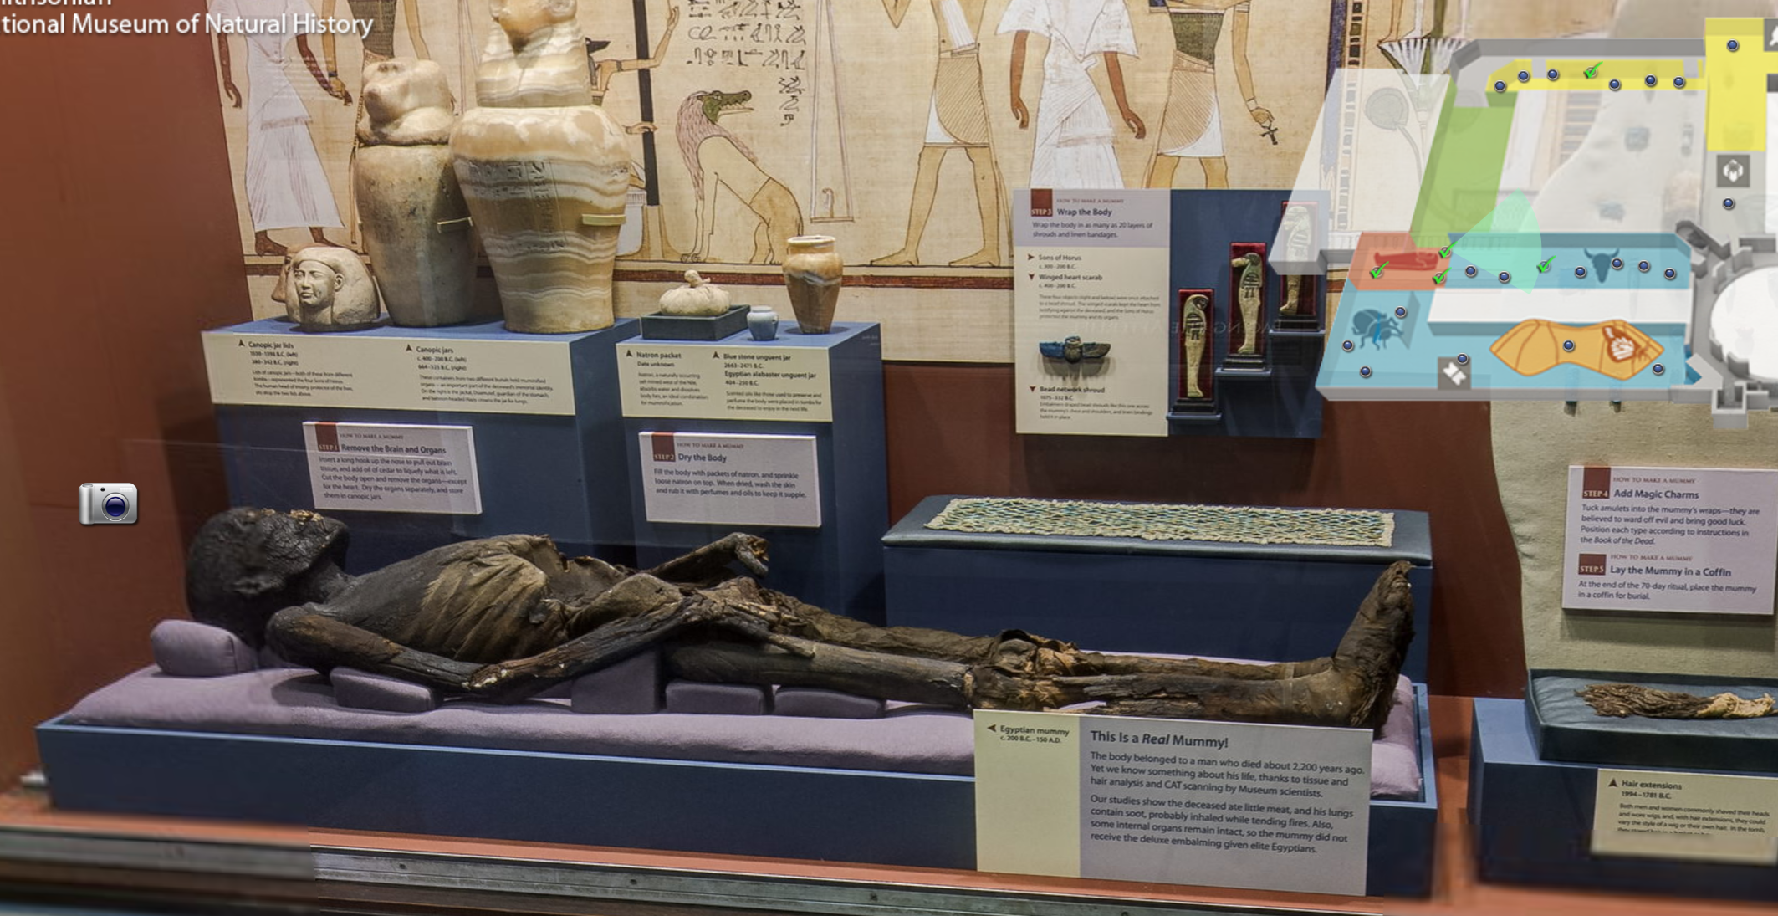
11 | 10 | =7million  “Garden 2”
12 | 80+40 | =Whole team needs to be in the picture and the museum in any form (ex a logo)  The 2 extra 20pts bonuses can be judged subjectively or if a score between teams is close then leave it up to teams to make a vote.
13 | 5 | =plesiosaur, tylosaurus
14 | 10 | = 15,500 – 11,500
15 | 20 | =35
16 | 30 | = Titanoboa
17 | 60 | = Grasshopper mouse  It’s a quote from exhibit description of a Grasshopper mouse.
18 | 5 | =Swordfish
19 | 15 | =Pronghorn
20 | 15 | = 1752
21 | 15 | =Mammal Hall: Africa 2
22 | 35 | =500 C  Some math is required by reading the description of below exhibit in the “Geology, Gems & Minerals: Space 3” hall  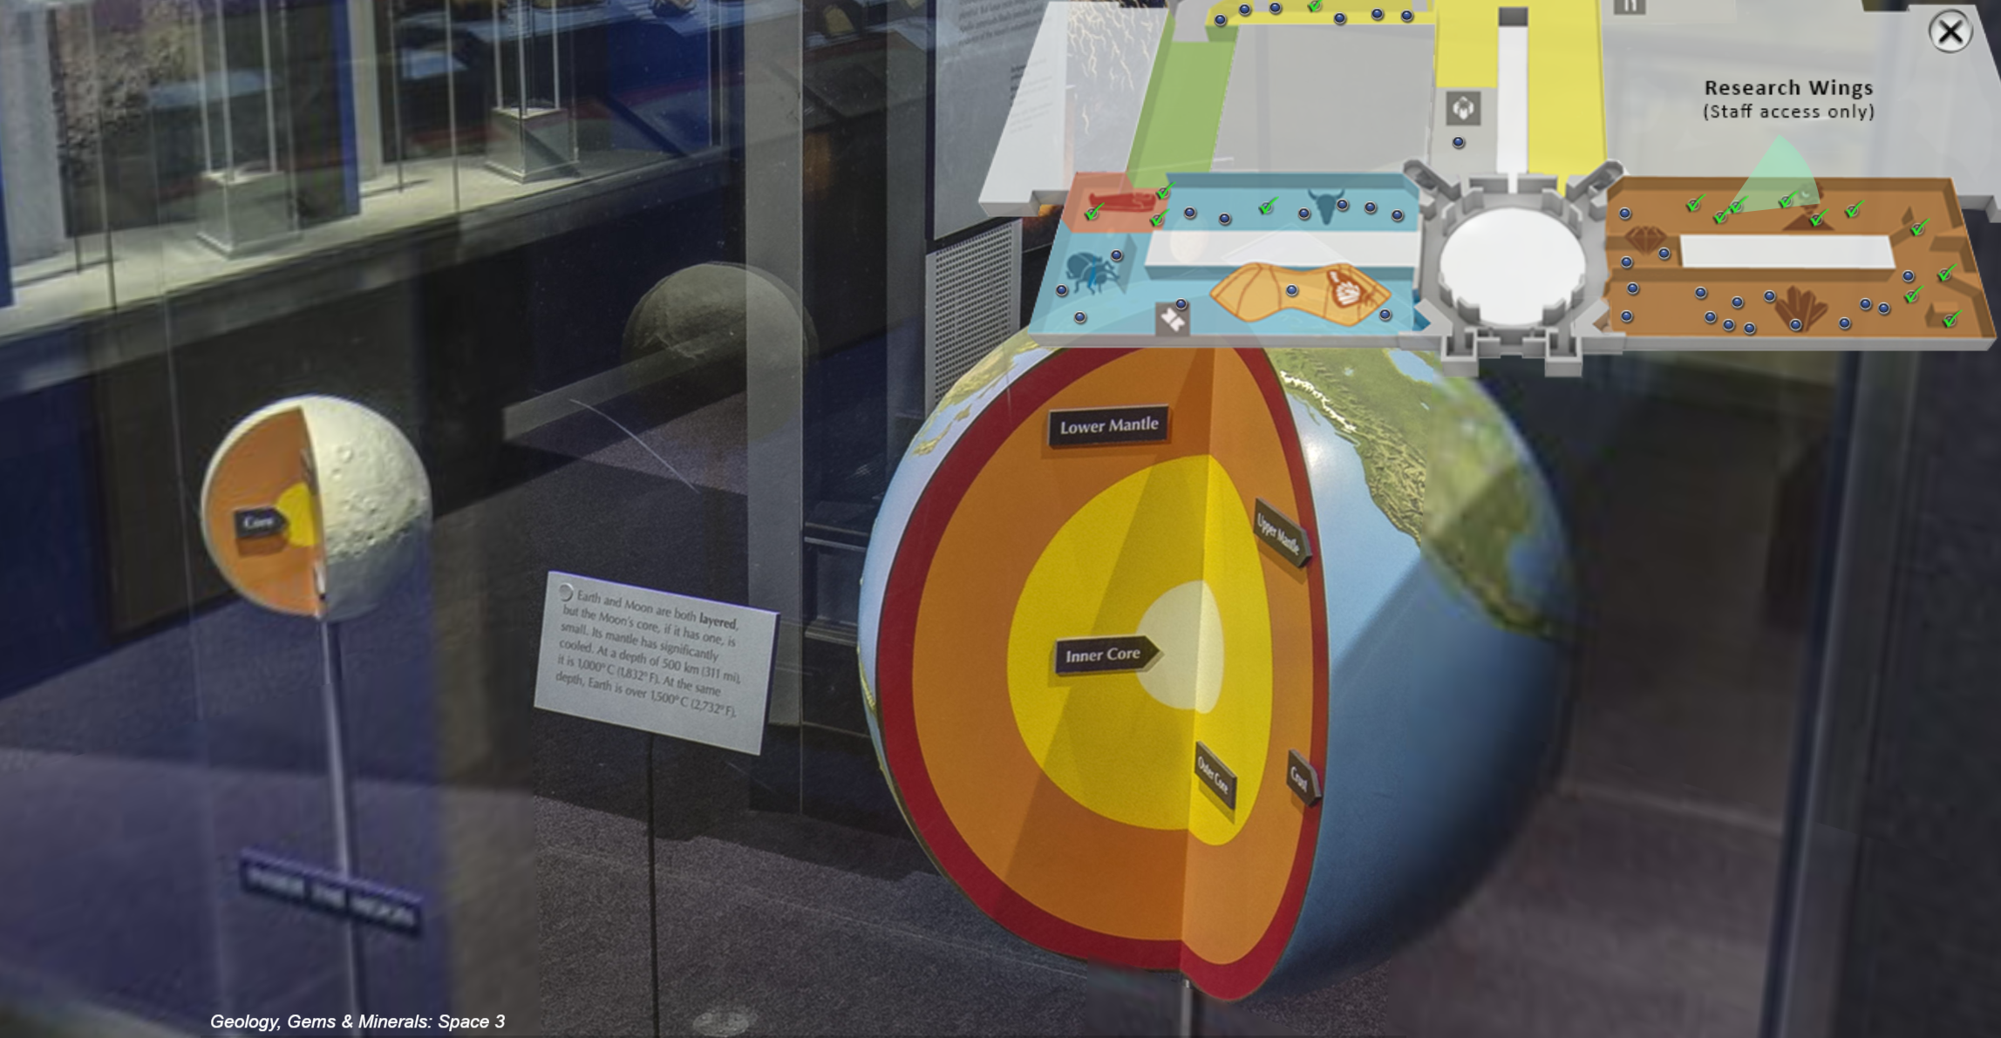
23 | 10 | = glyptodont
24 | 15 | = South America
25 | 10 | = ear bones
26 | 5 | It’s got it’s own room “Geology, Gems & Minerals: Hope Diamond 2”  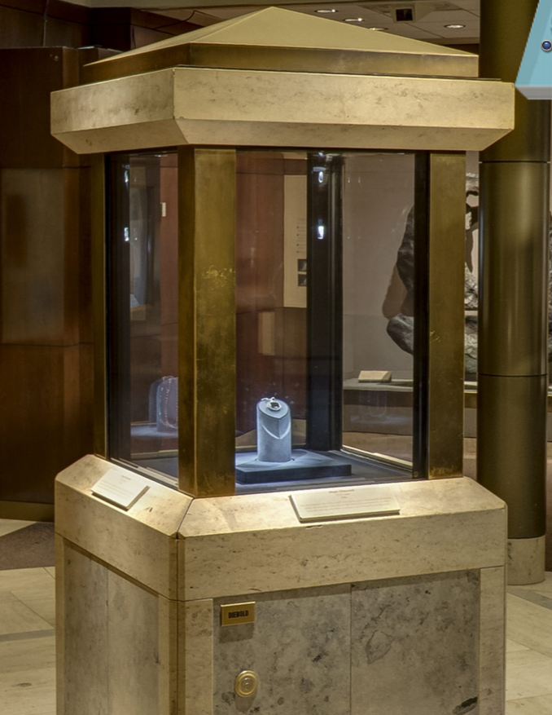
27 | 60 | =$2.06  Well hidden in the “African Voices: 5”, it’s the currency with a lion head and value is written beside it.  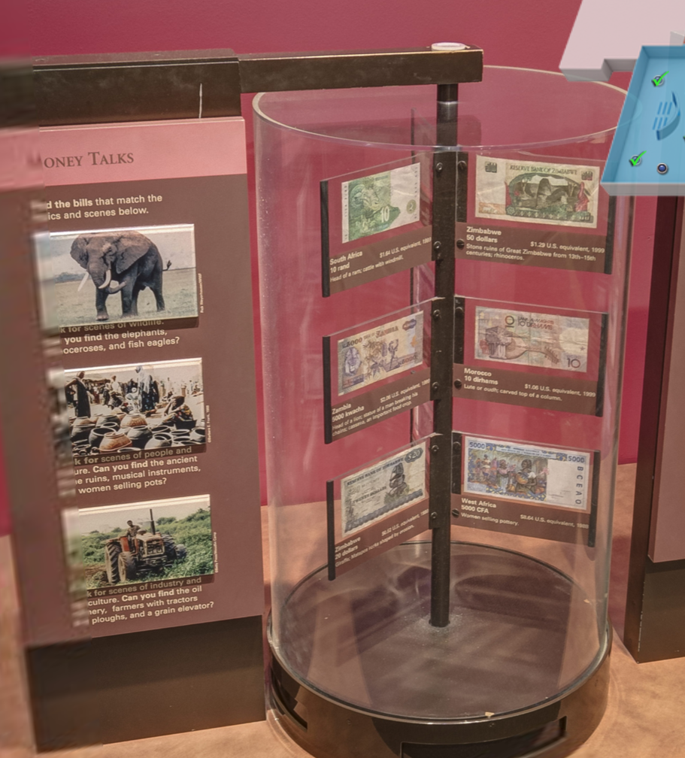
28 | 5 | = 530  It’s on the café menu.
29 | 20 | = Homo heidelbergensis
30 | 15 | =donors to the museum
31 | 30 | = 97% and one of giant herbivorous marsupial, giant goanna, flightless bird
32 | 10 | =microbes
33 | 15 | =1891
34 | 20 | =petrified wood
35 | 5 | =Human Origins: Lucy  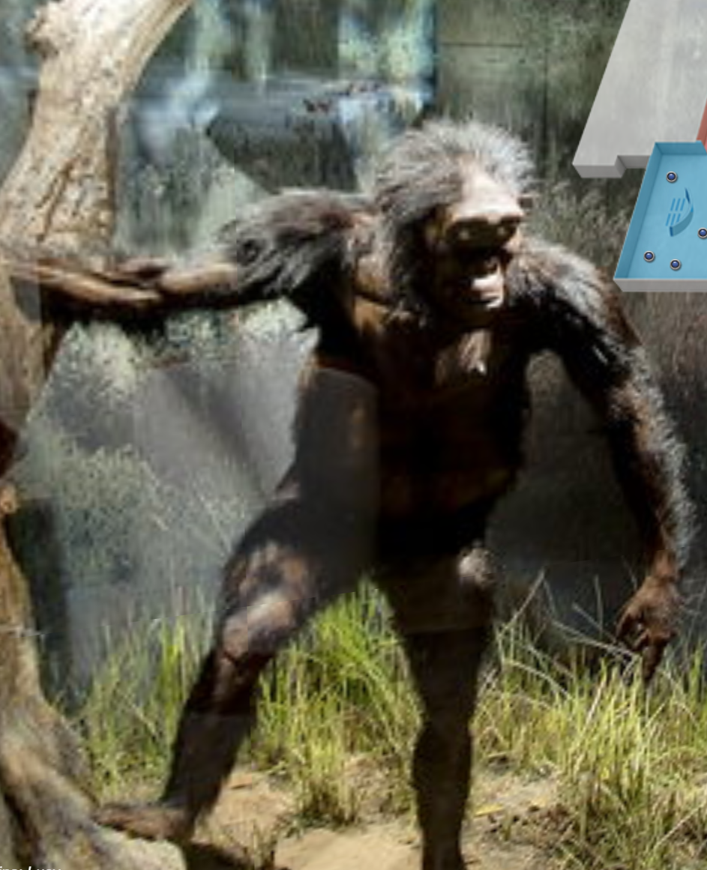
36 | 10 | =0
37 | 15 | =Tsimshian
38 | 70 | =It’s an apple on a tv by giant earth in the “Geology, Gems & Minerals: Earth 3” hall  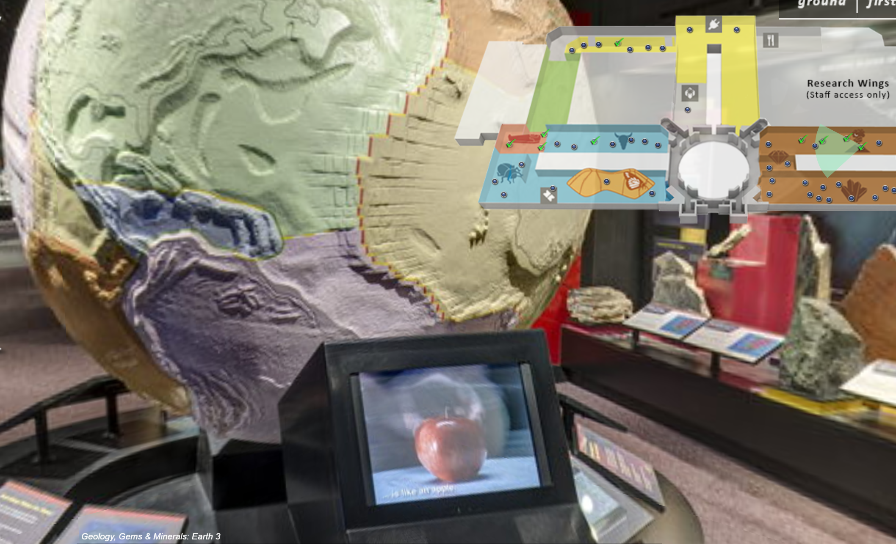
39 | 10 | = pteropods  In the Fragile Beauty art and science exhibit in the Sant Ocean Hall: Exploration.  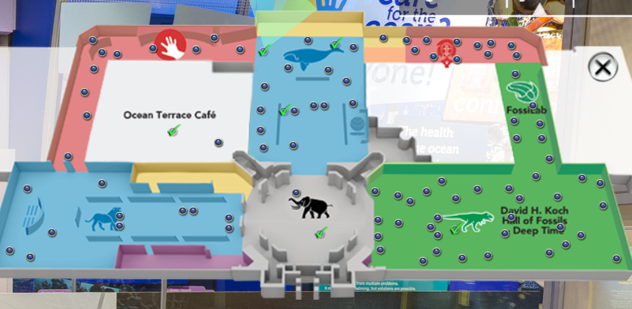
40 | 10 | =Kiti Cha Enzi
41 | 15 | =coming back from dead or being rediscovered  This fish was thought to be extinct until in 1938 it was caught and reclassified.
42 | 15 | =  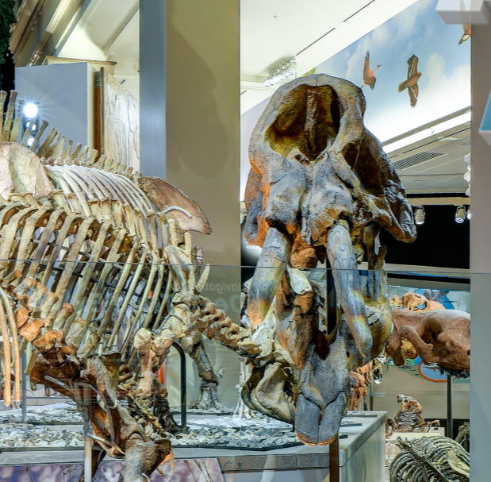
43 | 10 | =coffin
44 | 5 | = Sant ocean hall
45 | 30 | =in “A Riot of Evolution after a Mass Extinction” room  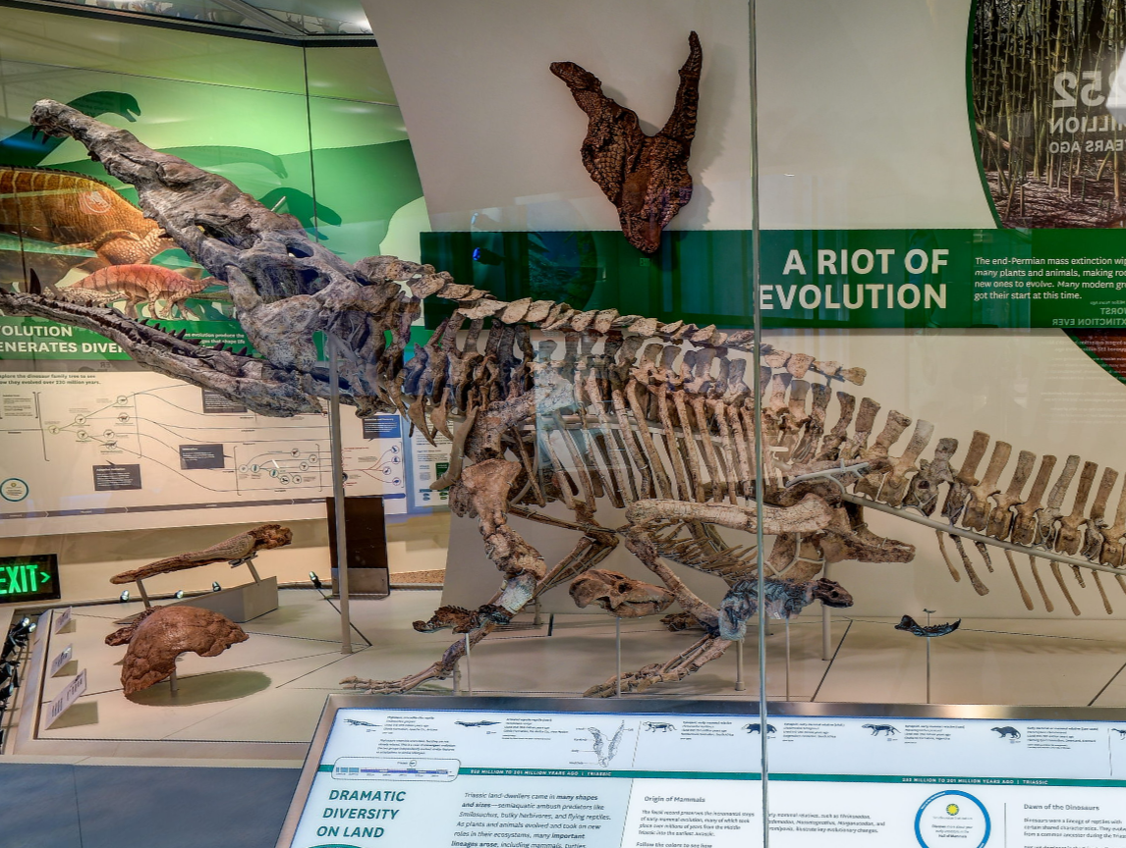
46 | 40 | =“Q?rius 7” is a classroom with chair #5  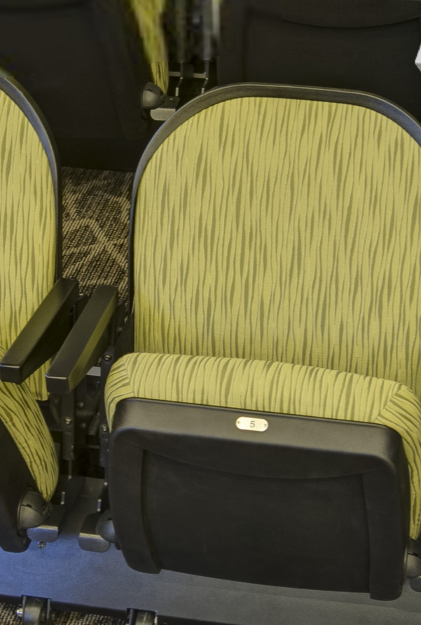
47 | 10 | =Luna moth
48 | 20 | = Namibia
49 | 60 | = TRINKET  Constitution Entrance 3  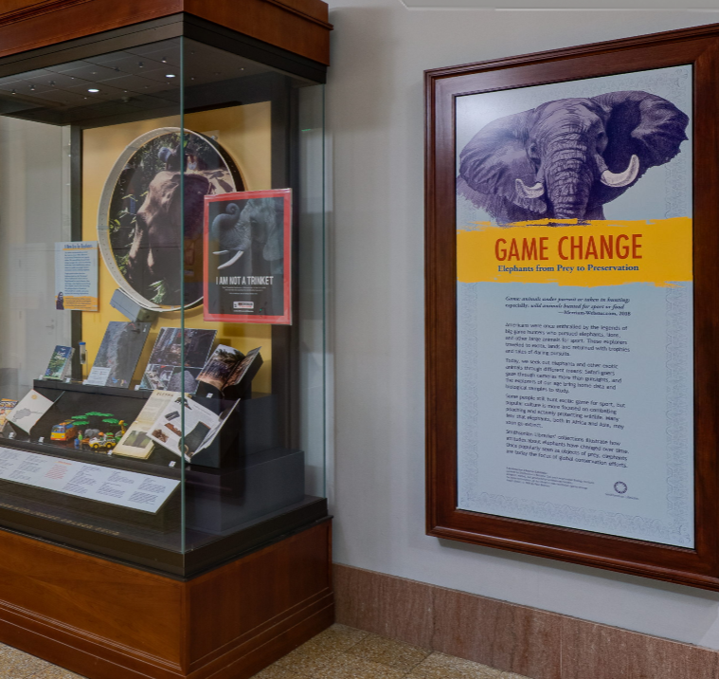
50 | 10 | =Look up! In the “Sant Ocean Hall: Arctic Ocean” room  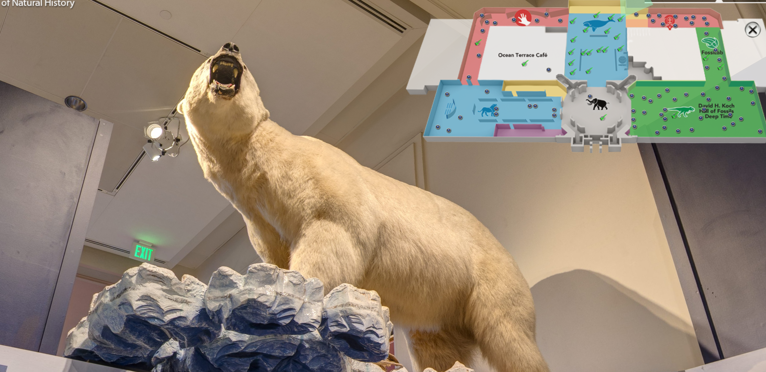
51 | 5pts | =in Sant Ocean Hall: Coral Reef  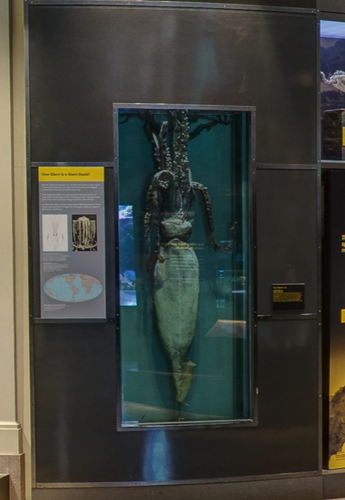
52 | 52 | =Constitution Entrance: 1  It’s the totem pole, the phrase is from a TV under it.  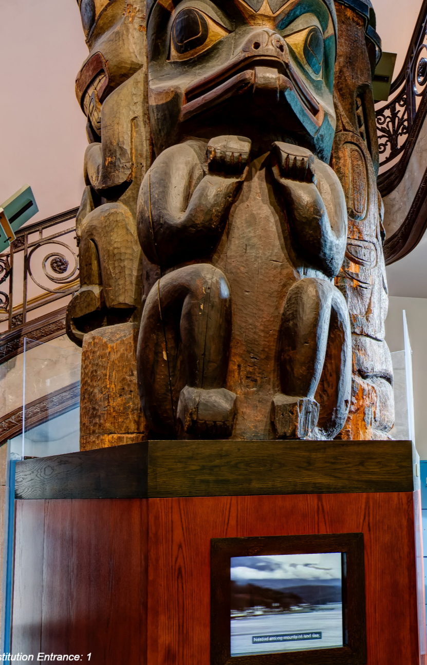
53 | 5 | = in “Birds of D.C. 1”  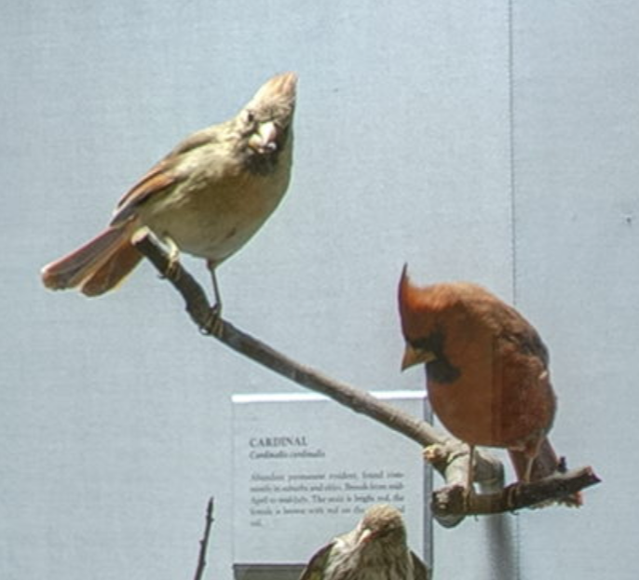
54 | 25 | =Swan in the “Birds of D.C. 2”  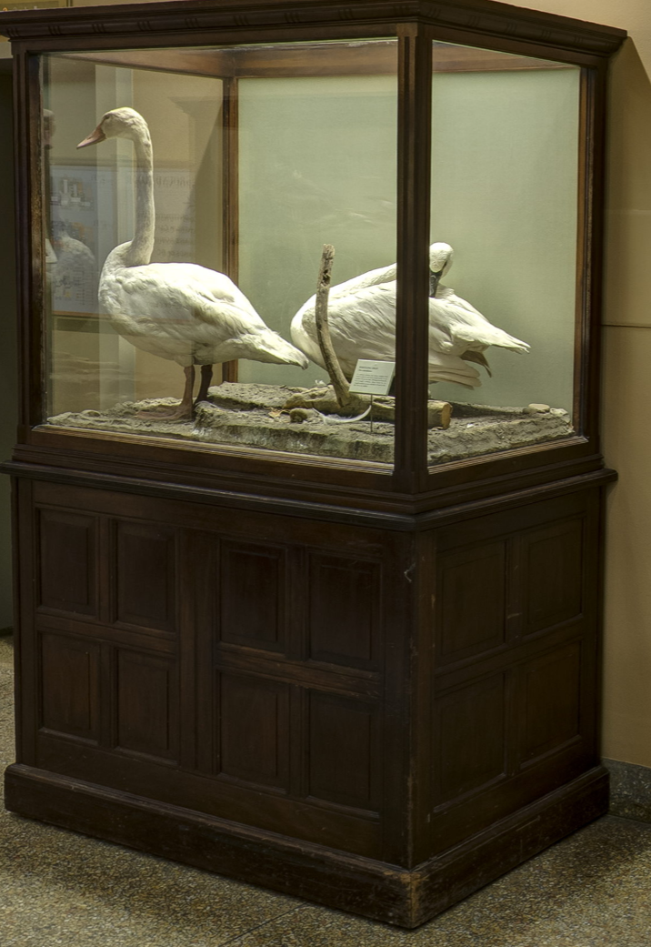
54 | 80 | =Fisher Crow is the answer and it lives in the “Birds of D.C. 2”  

